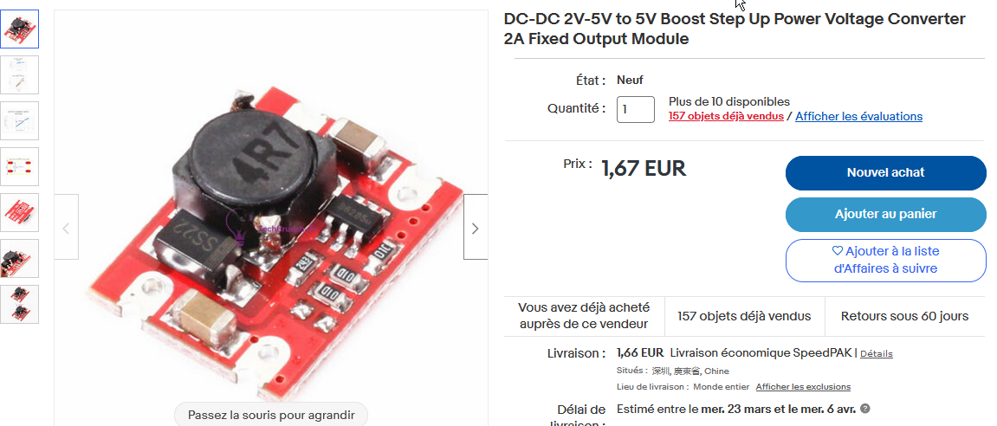

Description:
1. Input voltage:2.0V-5.0V
2. Output voltage:5V
3. Output current:2A(max)
4. PCB size:17*13mm
5. SMD
6. Conversion efficiency:95%

Package includes:
1/2/5PCS DC-DC 2V-5V to 5V Boost Step Up Power Voltage Converter 2A Fixed Output Module

